

Software Test Report

Contents
Overview 3
Testing phases 3
Planning 3
Method 3
Results 4
Analysis and conclusions 4
Software approval 5

Overview
This document is the Software Test Report of the testing phase of the [Click/tap to add software name] software development project.
[Click/tap to add some information about the context of the testing and the purpose of the tests.]

Testing phases

Planning
Plan the testing by completing the table below.
Table 1 – Test plan
Test ID | Test name | Summary | Expected result
Test 1 | Setting Breakpoints and Inspecting Variables | In a Python script, a breakpoint can be set on a line where a variable's value is expected to change unexpectedly. | When the program executes and reaches that line, it pauses, allowing inspection of the program's state at that point.
Test 2 | Stepping Through Code | After hitting a breakpoint, instead of letting the program run to the next breakpoint, use "Step Over" (F10) to execute the current line and pause on the next. | This is useful for observing the flow of execution line by line.
Test 3 | Print Method | This method helps to execute the programme to check whether it is running every step correct or not. | This will come up with error message in the Terminal.

Method
[Click/tap to add some information about the tests performed such as:
- when the tests were run
- who was involved
- what software version and/or platform was used.]

Results
Complete the table below with the test results. Include the Test ID (as listed in the Test planning), the actual results from the testing, screenshots of the testing and any relevant comments or information (where required), and the outcome of the test (did it pass or fail?).
Table 2 – Test results
Test ID | Test results | Screenshots of testing/ relevant comments | Test outcome  (pass/fail)
Test1 | To check whether the geodataframe (gdf) is correctly defined with the source file path.  It was found that the shapefile name is incorrect. | 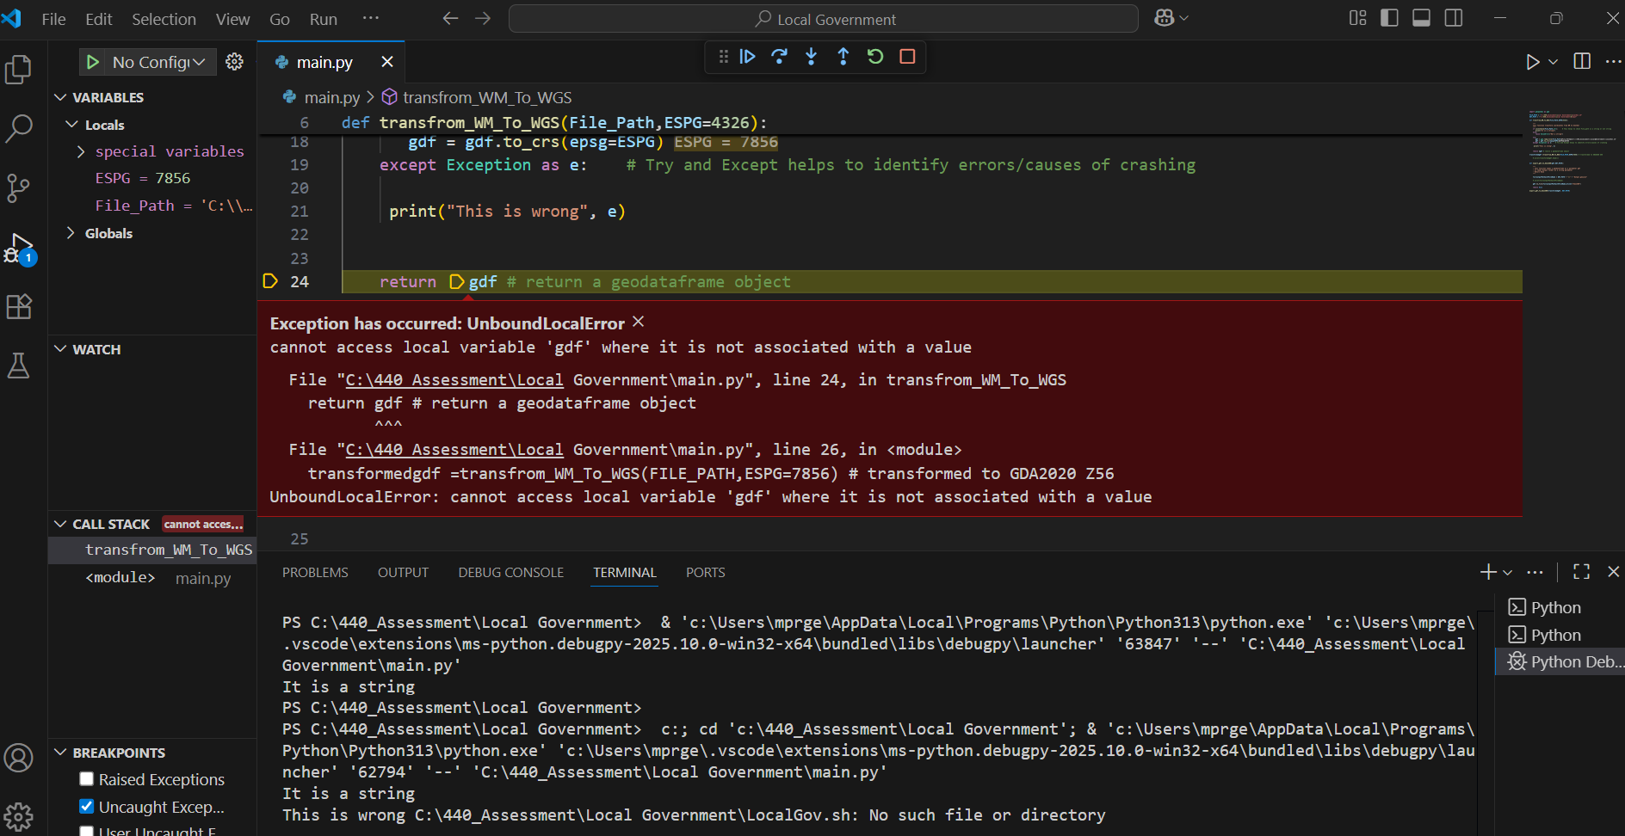 | Fail to run the programme.
Test 2 | Following Stepping Through Code method, it was aimed to see whether the source File Path is executed/linked correctly or not. | 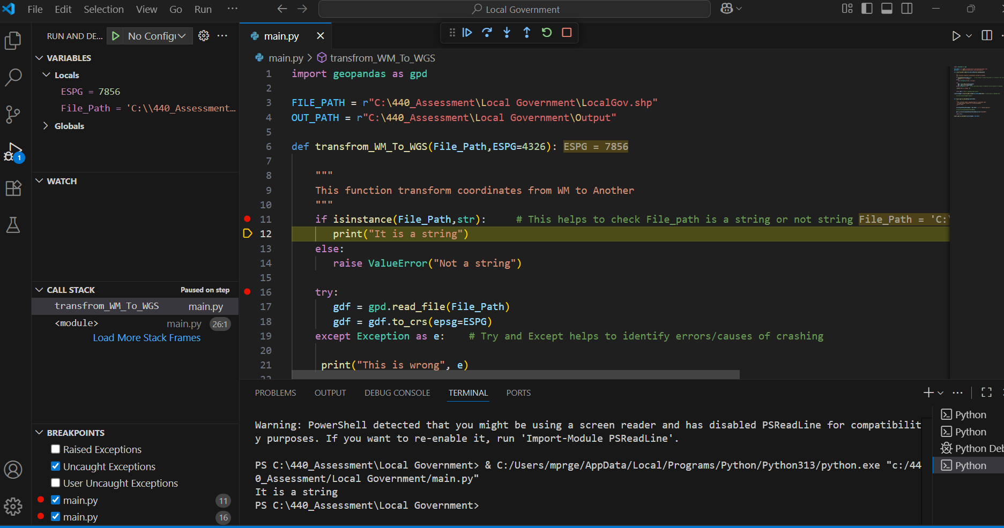 | Pass: It was executed correct and the result printed out as ‘It is a string’.
Test 3 | The simple Printing Method shows, I have put a wrong parameter. It shows “This is wrong name 'ESPGg' is not defined” | 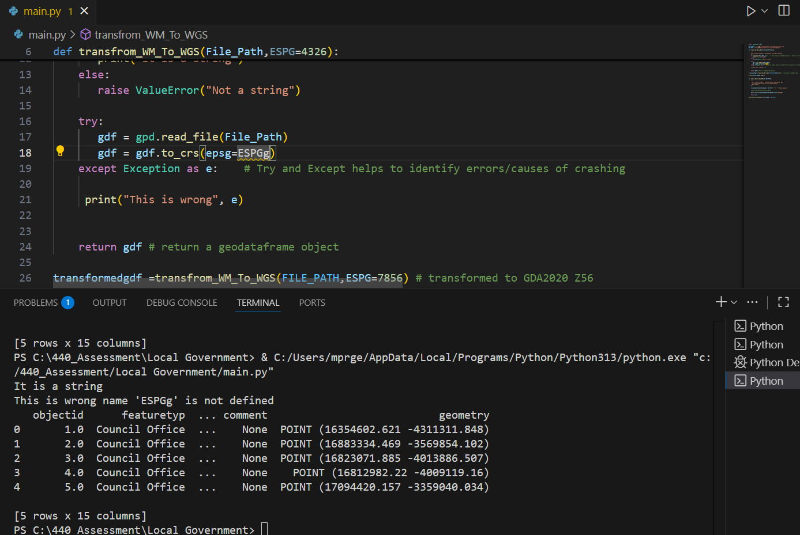 | Failed to execute as the parameter was not correct.

Analysis and conclusions
[Click/tap to add your analysis and conclusions from the testing. This may include:
- your analysis and identification of errors found
- any additional information and observations made during testing
- your evaluation of how well the software meets the specifications; use the table below or delete if not required.]
Table 3 – Software evaluation
Software specification | Evaluation
Data Source Validation: | Initial testing revealed that the shapefile name in the source path was incorrect, causing the program to fail. This highlights the importance of accurate file naming and path specification.
File Path Execution: | Stepping-through testing confirmed that the source file path was correctly linked and recognized as a string, demonstrating that the file connection process functions as intended when parameters are correct.
Parameter Accuracy: | Testing showed an incorrect parameter (‘ESPGg’) prevented execution, indicating that parameter names and syntax must be verified to ensure successful program operation.

Software approval
Software is approved for installation by:
Name
[Name of appropriate person approving the software]
Role
[Click/tap to select role]
Signature Date
[Click/tap to select date]

